**Talking about Visuals**

* **What are these visuals called in English? Match the numbers to the descriptions.**

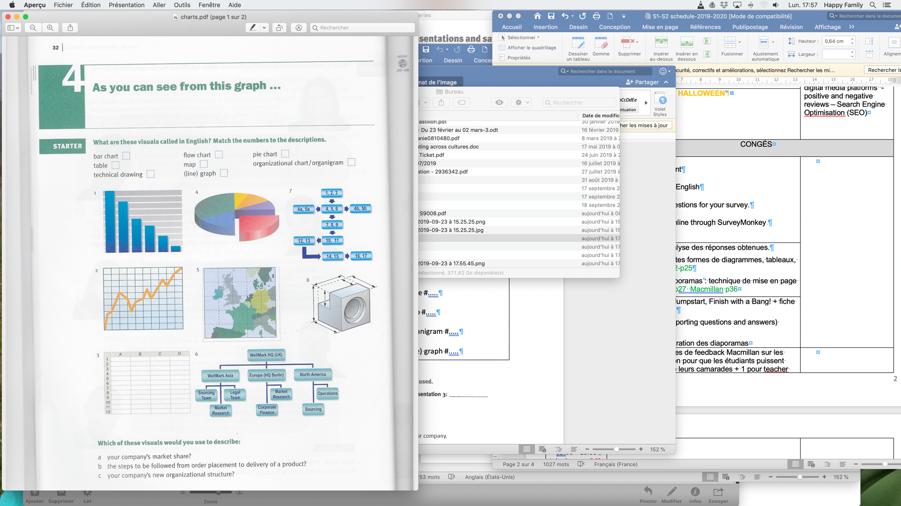

bar chart 1

flow chart 7

pie chart 4

technical drawing 8

table #3

map 5

organigram 6

(line) graph #2

Audio

Oxf-pres

26-27-28

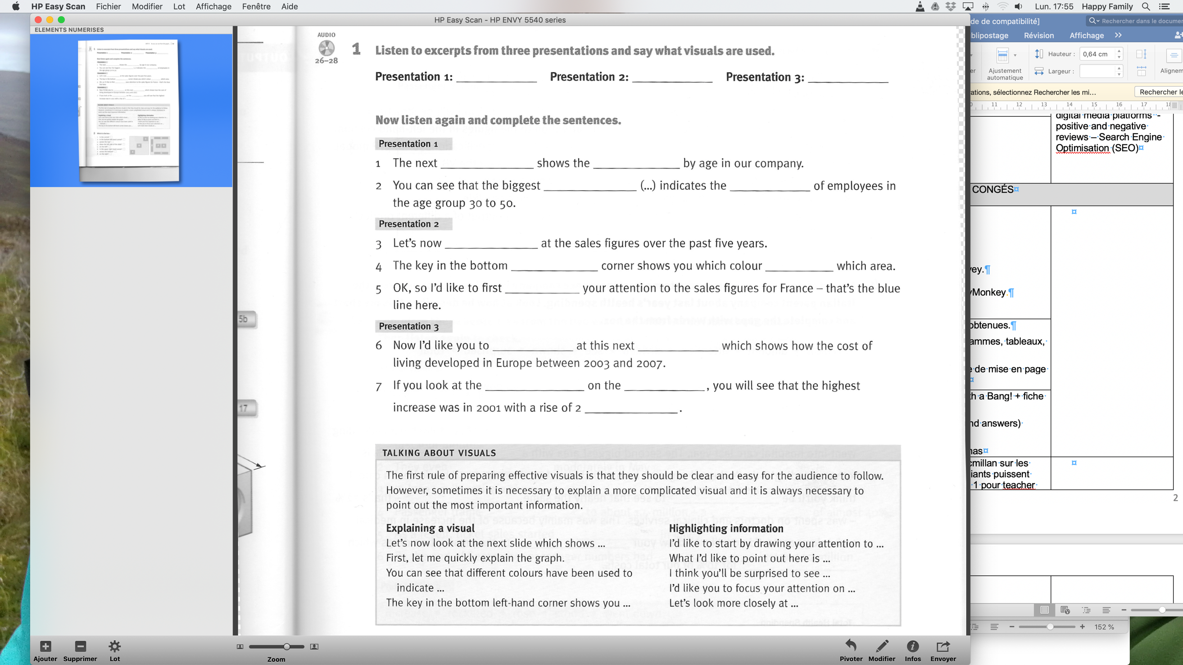

**Sayingnumbers**

**Remember that :** We use a comma in English to show thousands (10,000 = dix mille)

We use a point to show the decimal place (10.25 = dix virgule vingt-cinq)

We say “2 million”, and “2 million dollar**s**”.

100 = one hundred 1,000 = one thousand 1,000,000 = one million 1,000,000,000 = one billion

pie

The next chart shows the breakdown

The biggest segment indicate the percentage

graph

Let’s now have a look

Bottom left hand represent

Draw

presentation

Take a look slide

Bar chart on the left rise of 2 percent

This bar chart here represents the percentage of people that know Lipton. We can see that everyone know about Lipton.

This last bar chart here shows if people like products from Lipton and if they would recommend it to others. The green bar shows that 90 percent of people would recommend it so it is an appreciated brand.